**In Cisco Packet Tracer, create a small network with multiple devices (e.g., 2 PCs and a router). Use private IP addresses (e.g., 192.168.1.x) on the PCs and configure the router to perform NAT to allow the PCs to access the internet.**

**Task: Test the NAT configuration by pinging an external IP address from the PCs and capture the traffic using Wireshark.**

**What is the source IP address before and after NAT?**

NAT (Network Address Translation) is a technique used to convert private IP addresses into a public IP before sending data over the internet. This allows multiple devices within a local network to access external networks using a single public IP, making efficient use of available IP addresses.

**STEP FOLLOWED:**

My network consists of two routers, a switch, two PCs, and a server. The PCs (192.168.1.1 and 192.168.1.2) are connected to Router0 via a switch. Router0 is connected to Router1 using the public IP network 1.0.0.0/30. Router1 is connected to another switch, which connects to a server with IP 172.16.1.1.

To configure NAT, I defined the inside and outside interfaces on Router0. The interface connected to the local network (FastEthernet0/0) was set as the inside interface, while the interface connecting to Router1 (Serial0/0/0) was set as the outside interface. I created a NAT rule to translate private IP addresses (192.168.1.x) to the public IP 1.0.0.1, allowing internal devices to communicate externally.

After configuring NAT, I tested connectivity by pinging the external network (172.16.1.1) from one of the PCs. The ping was successful, and I captured the ICMP packets.

The output showed that my private IP (192.168.1.x) was translated to 1.0.0.1 before reaching the external network. This confirmed that NAT was working correctly, enabling internal devices to access external resources.

**Setting up the Packet tracer:**

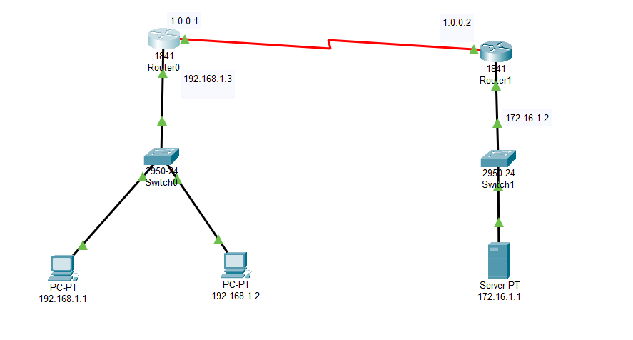

**NAT Configuration:**

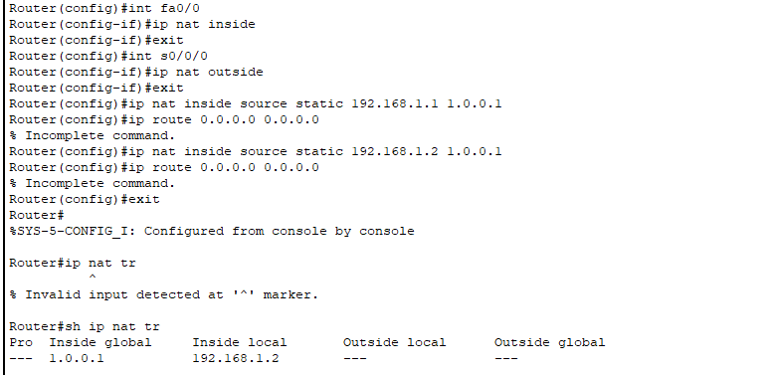

**Pinging 172.16.1.1 (external network):**

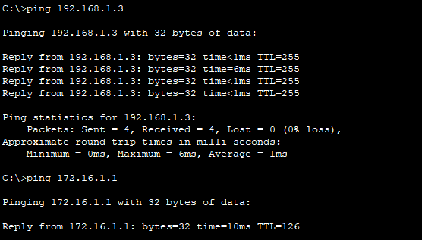

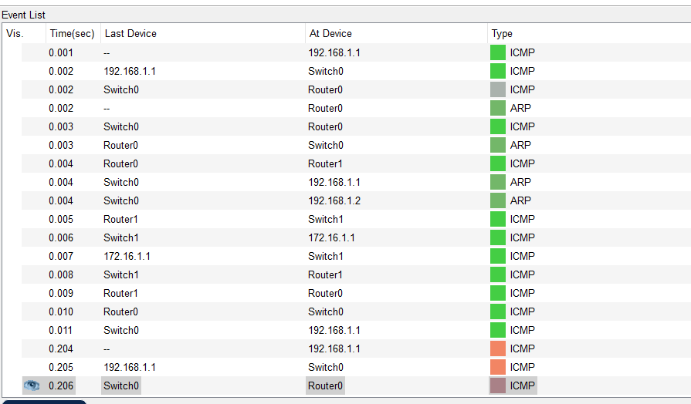



**The source IP address before and after NAT:**

**Router is translating 192.168.1.1 → 1.0.0.1 before forwarding packets to 172.16.1.1.**

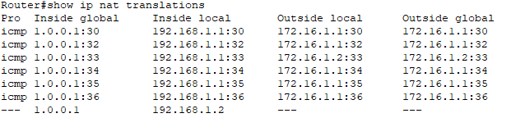

**Observations**

* Ping from PC to 172.16.1.1 was successful, confirming NAT is working.
* The source IP changed from 192.168.1.1 (Inside Local) → 1.0.0.1 (Inside Global) before reaching the external network.